Communication Skills: ABC Principle

Your communication should always be ABC:

A = Accuracy  
B = Brevity  
C = Clarity

A: How to make your communication more Accurate.

Accuracy means two things:

* Accurate in the sense of being factually accurate
* Accurate in the sense of using accurate grammar

Accurate facts: Always check your facts. Check your sources. The world is full of fake-news and the responsibility is on you to ensure that what you say is *factually accurate.*

Accurate grammar: Your facts may be accurate, but your grammar may be ambiguous. For example:

* When I nod my head, that's the signal for you to hit it.
* I will call you soon/ as soon as possible.
* See you soon.

You need to be sure your writing is accurate in both content and grammatical structure.

B: Be Brief

The message must be sufficiently brief to allow the listener or reader to "*take it in".*

If you present too much information, then most people will be put off.

Cut all non-essential items.

C: Make Sure You are Clear

Clear means clearly defined. All concepts must be clearly defined.

There are three ways to clearly define your meaning:

1. By using numbers:

Rather than saying, "taxes are too high". Say "VAT is currently 20% and it should be reduced to 17.5%"

2. By using definitions:

Give definitions of ambiguous words. For example; "Power" is a measure of the amount of work done in a unit of time.

3. By using images:

Often a picture is worth a thousand words.

For example, have a look at the diagram below and I think you will immediately see what it means. But to explain without an image, would be quite tricky.

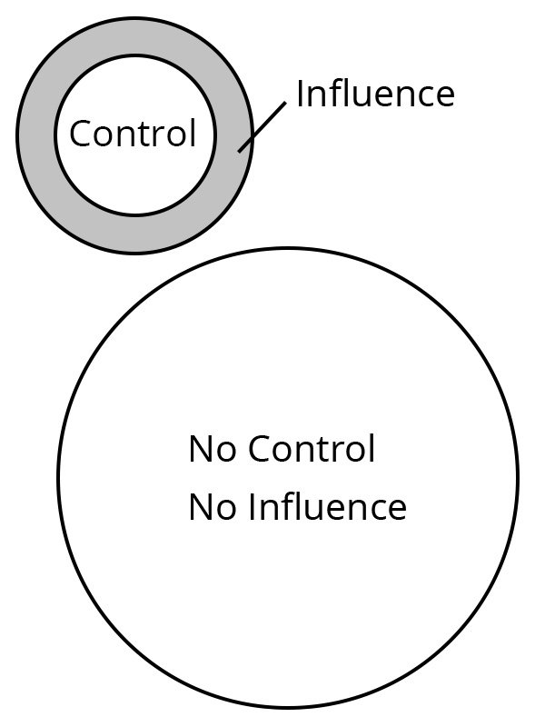

Summary

Your communication should always be:

A = Accurate: Facts and grammar  
B = Brief: Edit all non-essentials  
C = Clear: By giving numbers, definitions or images.